

To find the your legislators, scan the QR Code or visit:

<https://www.nmlegis.gov/members/find_my_legislator>

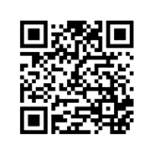

# Every Voice Shapes Healthcare in New Mexico!

New Mexico deserves better access to medical care. Use your voice to tell legislators about the need for more providers or other issues affecting healthcare. Scan the QR code to find your legislators and make a change today. Help make healthcare a top legislative issue in NM!