

To find the your legislators, scan the QR Code or visit:

<https://www.nmlegis.gov/members/find_my_legislator>

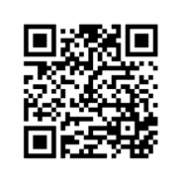

# **Your Voice,**

# **Your Health**

Speak up for better healthcare in NM! Contact your legislators about waiting times, doctor shortages, and other crucial issues. Be a part of the change that improves conditions for patients across the state. Scan the QR code to find your legislators and share your concerns.